Name Date

Test B

Chapter

2

1. Order the numbers from least to greatest.

Answers

1.

2. See left.

3. See left.

4.

5.

6.

7.

8.

9.

10.

11.

12.

13.

14. a.

b.

15.



Complete the statement using 

2.  3. 

Find the distance between the two numbers on the number line.

4. 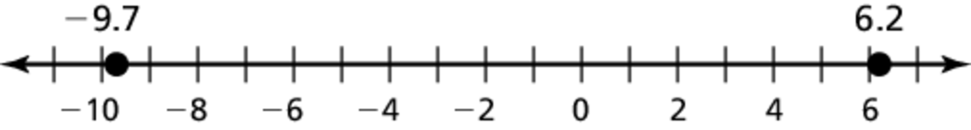

5. 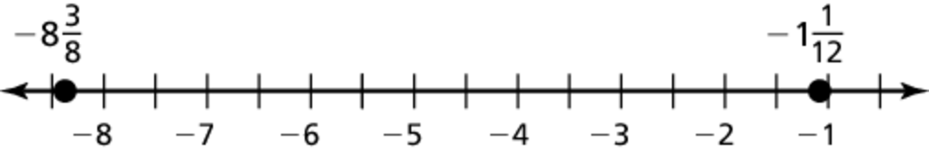

Add or subtract. Write fractions in simplest form.

6.  7. 

8.  9. 

Evaluate the expression when 

10.  11. 

12.  13. 

14. You spendhours hiking and an additionalhour to rest.

a. How much time did you spend hiking and resting?

b. How much more time did you spend hiking than resting?

15. Find a repeating decimal between 

Name Date

Answers

16.

17.

18.

19.

20.

21.

22.

23. See left.

24.

25.

Test B **(continued)**

Chapter

2

Evaluate.

16.  17. 

18.  19. 

20.  21. 

22. The table shows the changes in rainfall (in inches) from the monthly average of four months. What is the mean change?

|  |  |  |  |  |
| --- | --- | --- | --- | --- |
| Month | May | June | July | August |
| Change (inches) | 1.05 | –0.58 | –2.12 | –2.67 |

23. A recipe calls forcups of sugar. You havecups of sugar.   
Do you have enough sugar? If not, how much more sugar is needed? Explain your answer.

24. A 10.5-gallon aquarium isfull. How many more gallons of water does it take to fill the aquarium?

25. How many 0.45-ounce packages of cinnamon can be made with   
3.15 ounces of cinnamon?