Name Date

Quiz

For use after Section 2.4

Chapter

2

Subtract. Write fractions in simplest form.

1.  2. 

3.  4. 

Find the distance between the two numbers on the number line.

5. 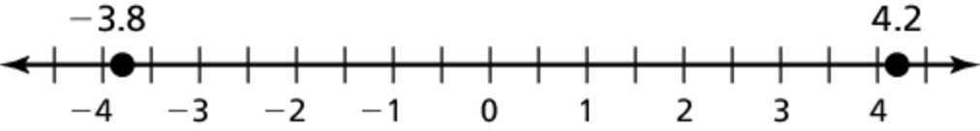

6. 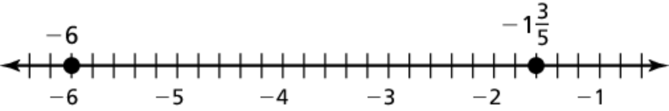

Multiply or divide. Write fractions in simplest form.

7.  8. 

9.  10. 

Evaluate.

Answers

1.

2.

3.

4.

5.

6.

7.

8.

9.

10.

11.

12.

13.

14.

15.

11.  12. 

13. A bottle contains 16.9 fluid ounces of water. After you take a sip,   
the bottle is  full. How many fluid ounces is your sip?

14. Your class is holding a fundraiser for a local charity. After the first week, your class raised  of your goal. After the second week, your class raised a total of  of your goal. What fraction of the goal was raised during the second week of the fundraiser?

15. Stock A changed by during the day. Stock B changed by  times that amount. How much did Stock B change during the day?